The Methodist Church
Winchester, Eastleigh and Romsey Circuit

Action for Hope: Step 2 Green your energy

The Methodist Conference has affirmed the Action for Hope programme to achieve a carbon net zero profile by 2030. Step 1 is Assess where you are, and this is the baseline for Step 2: Green your energy. A valuable bridge between these steps has been provided by the Property section of the Methodist website with Take first steps. This includes the very helpful net zero carbon checklist which is available on the Circuit website to download. We recommend using this check list as you make your plans to Green your energy. At this time the drive to make our investments in energy very efficient is of increased importance to the help us find the resources to realise our mission locally as well as being part of creation care and climate justice.

Objectives
Rather than seeing our missions scaled back by the increased energy costs, we have an opportunity to reassess our priorities. We have opportunities to live with our communities in manner mindful of Our Calling to The Methodist Way of Life. Some steps to carbon net zero are relatively low cost and can reduce our energy consumption and/or our carbon footprint. Others require lengthy consideration and longer term planning and in that process we should assess if we can achieve reductions in both our energy costs and carbon footprint. I have published two YouTube videos on Step 2: Maintenance and Lifestyle and Panels and pumps.

In the last couple of years we have learnt the importance of air quality as a component of a safer space. Covid-related hospital admissions in England were reported as 5930 in the week ending September 26, an increase of 48% over to the previous week. We should not unlearn understandings that were hard-won.

Here is a breakdown of the effect of relatively low cost and of larger outlay possibilities with regard to their effect on cost, energy use and carbon footprint. A selection of these appropriate to your site may reduce cost and carbon footprint

Maintenance, lifestyle, fuel
Energy and carbon reducing
Reducing set temperature to avoid overheating
Adjusting the timing of heating around usage.
Improving insulation: glazing, curtains, draft reduction, flooring, ceilings, walls.
Changing lighting from incandescent to LED (uses 1/10 of energy) or from low energy (CPL) (uses 1/5 energy of incandescent bulbs).
Change an inefficient radiator or heater with an efficient fan heater. If this involves changing from gas to electricity the cost might increase
Carbon reducing
Moving to a supplier utilising renewable sources only or low-carbon sources (i.e. renewables-nuclear mix)
Carbon offsetting using an ethical agency e.g. Climate Stewards and Woodland Trust
Cost reducing
Moving to a fuel tariff based purely on cost.

Infrastructure change
Net energy and carbon reducing
Installation of a highly efficient fuel system
Installation of heat exchanger system so that incoming clean air is heated indirectly by the expelled air.
Installation of solar panels with a properly scaled battery system. This also provides some emergency power during power cuts
Installation of heat pump (Air source or ground source to heat water- or air-based heating systems)
Net carbon reducing
Changing fuel sources from coal or oil to gas to green electricity.
Installing solar panels without a battery system: Very little is collected and used.
Cost reducing
Using a batteries to shift electricity consumption from peak low off-peak tariffs

Relative effects
These show the daily energy consumption of our home for each month over the last year. Each value is the average over the previous 12 months. Suppliers will aften use this history to estimate your future payments.

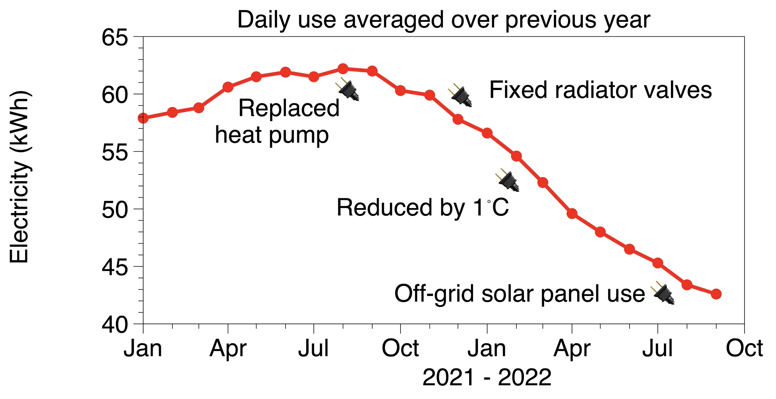
The annual consumption of this all-electric system has reduced by ~⅓. This journey has involved a combination of a necessary replacement of the 11 year old heating system, fixing radiator thermostatic valves and reducing the set-temperature of the central heating. The effect of moving the recharging and use of hand-held tools, electric bike and computing equipment to solar-generation is not yet clear, but should be relatively minor (~ 1kWh per day or less).

The breakdown of the electricity use in a given month is shown next. The figures for the solar panels are those of Romsey Methodist Church are included – this is very similar to what might be fitted to our house (4 kW peak power). With the reductions in use, consumption in the warm months is comparable to that generated by a 4kWp solar panel system with a battery system of enough capacity to capture the daily summer use.

The summer energy use is dominated by consumption that is other than the heating system. In the summer the heat pump is only used to generate the hot water supply. Over the year that use about 14% of the heat pump consumption. The bulk of the heat pump energy is during the winter for space heating of the house.

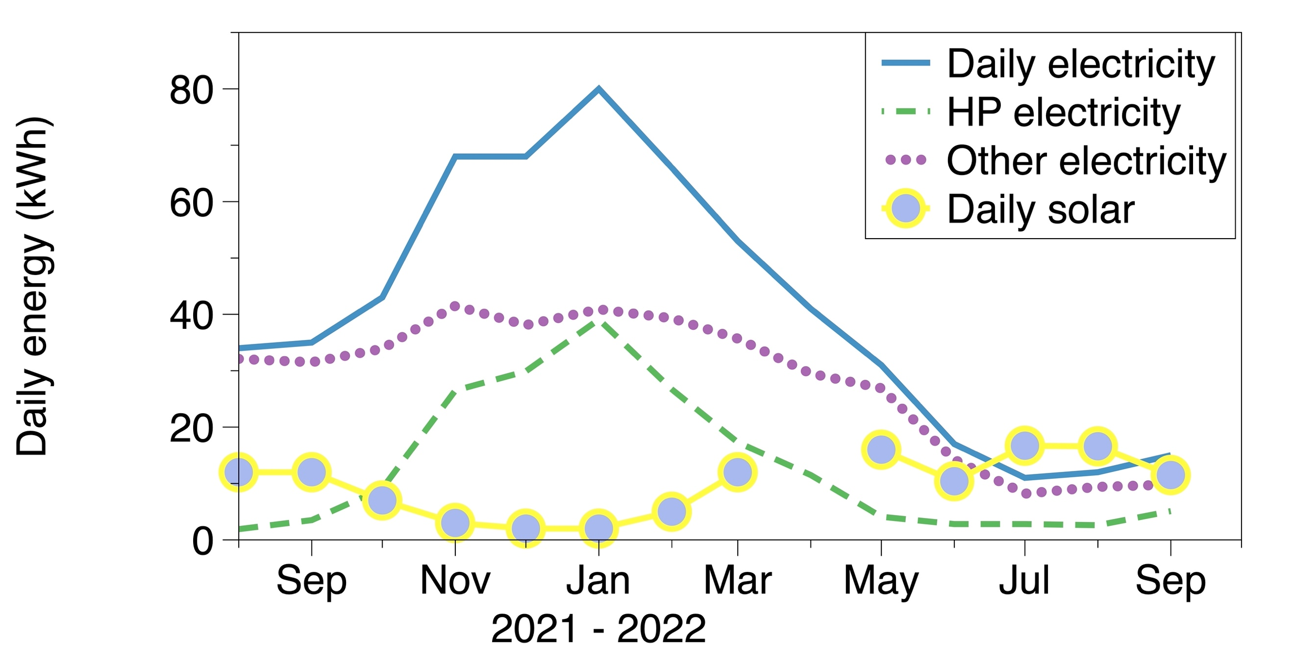
In the cold months the situation is quite different. The energy used by the heat pump is similar to that of other uses and this dwarfs the output of the solar panels.

What is not shown so far is the energy collected by the heat pump. The overall energy consumed in the house is shown by the red curve below. The energy collected by the heat pump essentially reduces the electricity consumption overall by about a factor of 2; the gain by the heat pump over its electricity is ~3.8.

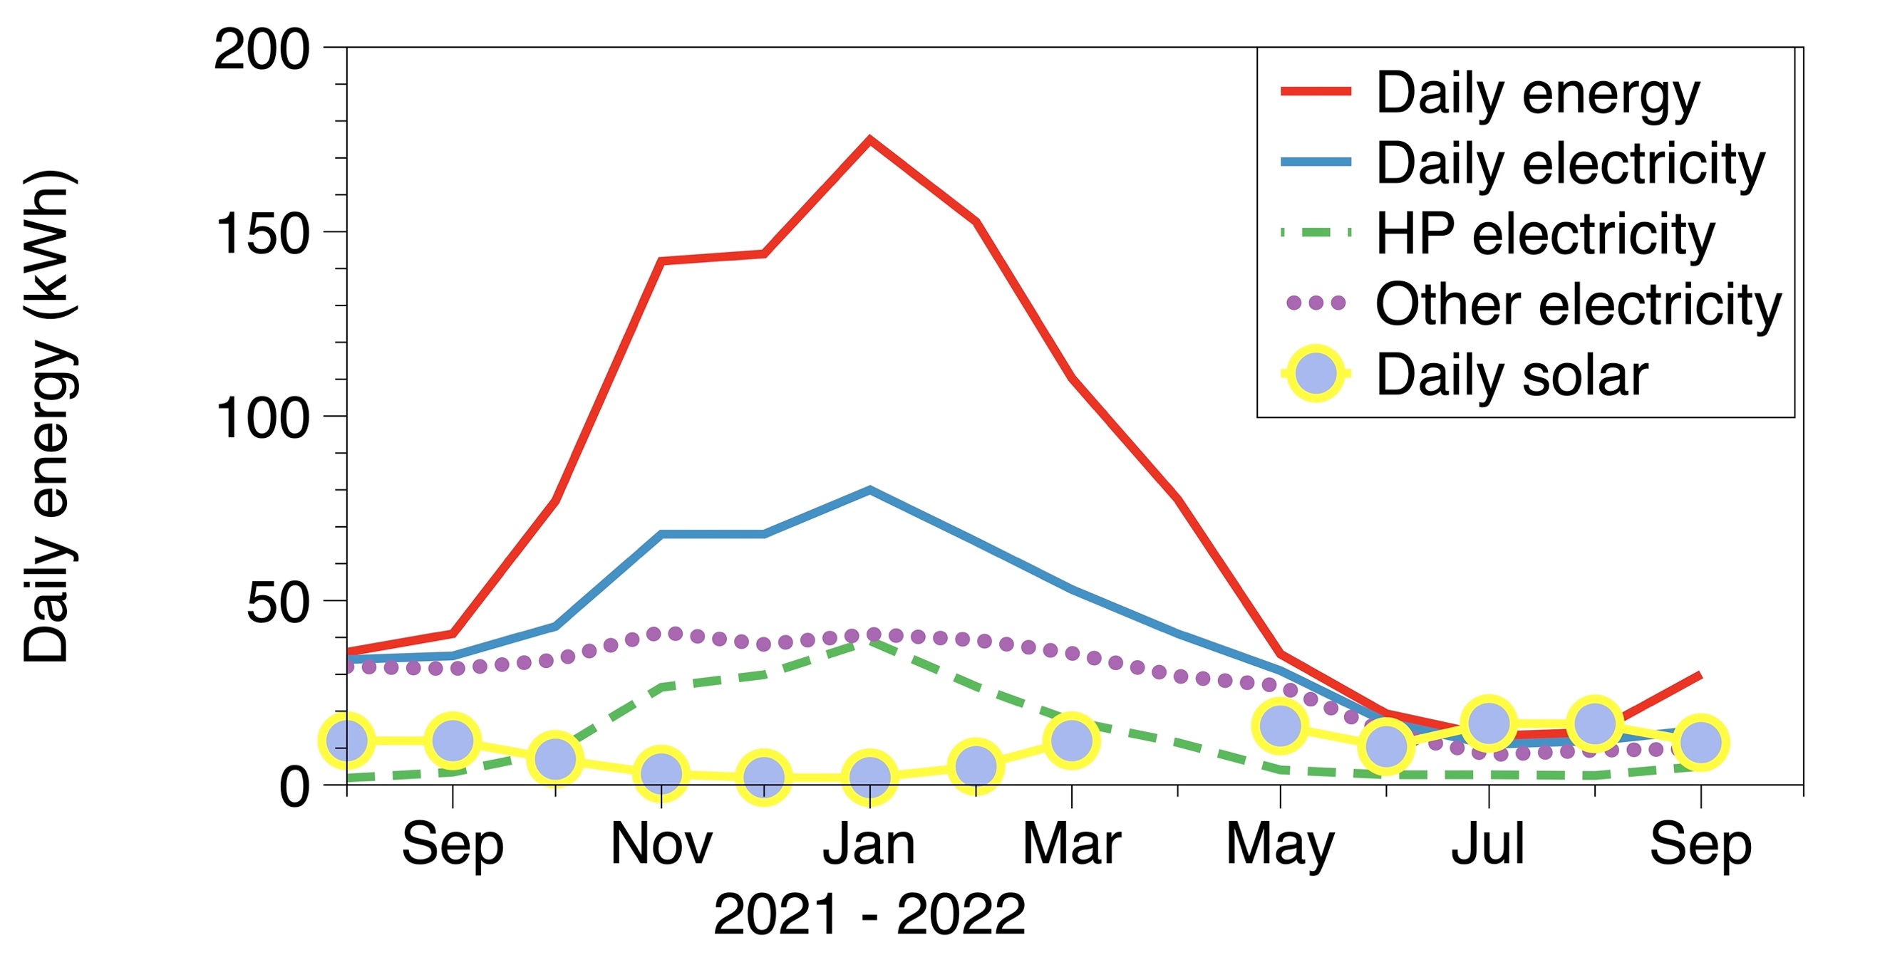
These curves will vary considerably between locations, but the general shape of the component factors might be expected to the pretty common: space heating is the most important and is largest in the winter. It seems wise to start with the lower cost items when Greening your energy. As you look into the effects these have you will have a better of understanding of the appropriateness of any larger investments.
John Evans (01794 368434; johnxafs@icloud.com)

